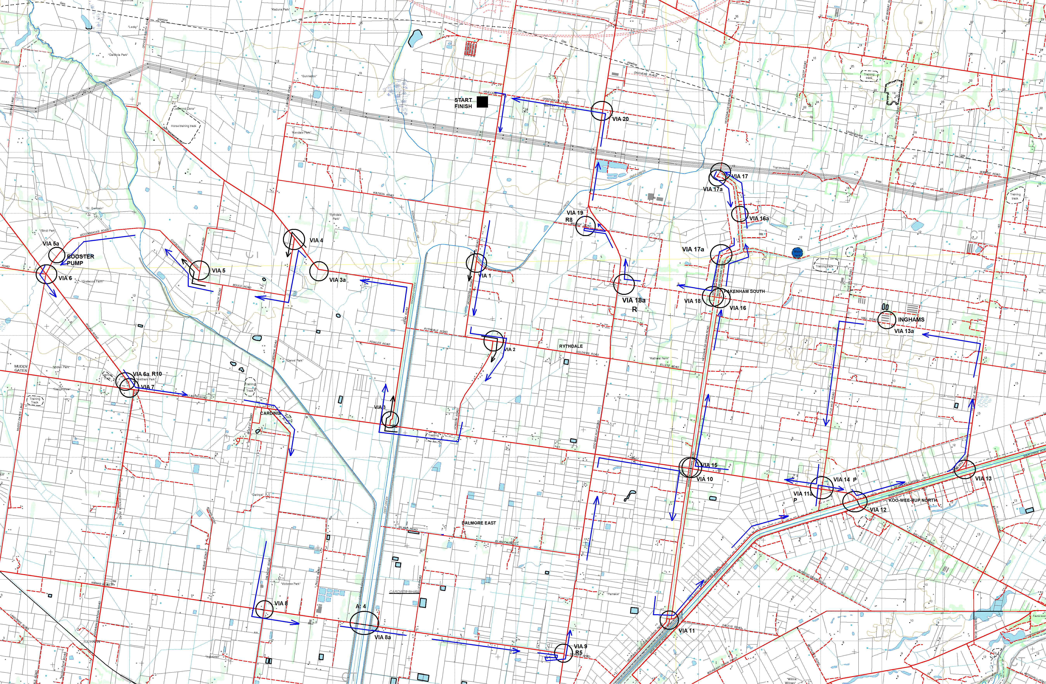
SECTION 1 ROUTE MAP – ALL VIAS

